PDA Stats Manual

Statistical Software for Palm and Pocket PC Devices

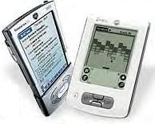
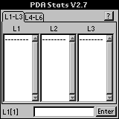

PDA Stats Manual

PDA Stats was developed with SuperWaba. This software is designed for education as a supplement to any introductory statistics class and for small business applications. PDA Stats will run on Palm and Pocket PC Devices and has six built-in lists for storing and editing data. The program provides a wide variety of descriptive and inferential statistics procedures. Users may construct a histogram, box plot, or scatterplot, and compute summary statistics including the mean, median, variance, standard deviation, quartiles, and correlation. Common confidence intervals and hypothesis test procedures are also included.

PDA Stats contains functions for regression analysis, analysis of variance, and goodness of fit tests. Users may also generate random numbers from a variety of distributions, compute permutations and combinations, and find probabilities associated with common discrete and continuous distributions.

If you have any questions, suggestions, or wish to report a bug, please contact us at skokoska@bloomu.edu. For more information and news about PDA Stats, please visit our web site at http://facstaff.bloomu.edu/skokoska/pdastats/home.htm.

PDA Stats is currently the most powerful statistical application for handheld devices. This software project is an ongoing development task, sensitive to user concerns and suggestions, and has taken a development team 13 months to create and bring to market. We hope you agree PDA Stats is the best and most robust statistical package available for your PDA.

Authors:
Software Development: Stephen M. Kokoski, Ph.D.
Programmer: Shawn O’Brien
Manual: Amy Tribendis

Table of Contents

Getting Started: Read This First! 1
Installation 2
How to Start the Program 2
Example: Entering the Data 3
File: 4
List Options 4
Preferences 5
Import 5
Export 5
About ? 5
Exit & Save 5
Exit 5
Plot: 6
Pie Chart 6
Scatter Plot 6
Line Plot 7
Histogram 7
Bar Chart 7
Box Plot 8
Normal Prob Plot 8
Calc 9
1-Var Stats 9
2-Var Stats 9
Regressions 10
Probability 12
CorrMat 14
Dist 15
Inverse 15
Discrete 16
Continuous 17
Test 20
Z-Tests 20
t-Tests 21
Proportion 22
Variance 22
Chi-square GOF 23
Chi-square 2-way 23
ANOVA 23
ANOVA 2-way 24
Nonparametrics 24
Int 26
Z-Intervals 26
t-Intervals 26
Proportion 27
Variance 27

Getting Started: Read This First!

PDA Stats is a powerful statistical tool for handheld devices. All statistical analysis will be done using data in lists. Data can be manipulated in many ways using PDA Stats. PDA Stats contains six built-in lists. The list editor is used to enter, edit, organize, and store data. Data can be imported and exported easily. Each screen has built-in tabs for easy navigation.

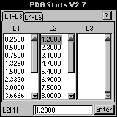

An Example of the List Editor

Installation

*Important: If you have PDA Stats V1.0, V2.0, V2.1, V2.2, V2.3, 2.4, V2.5, or V2.6 already installed, please uninstall it by using the included uninstall program that is located in the program group under the Windows Start menu at Start > Programs > PDA Stats > Uninstall PDA Stats. This will remove PDA Stats from your PC, however you still need to remove it from your Palm OS handheld. To do this, on your Palm OS handheld, please delete all files, including: PDA Stats, SuperWaba, and SWNatives before proceeding with the installation of PDA Stats V2.7.
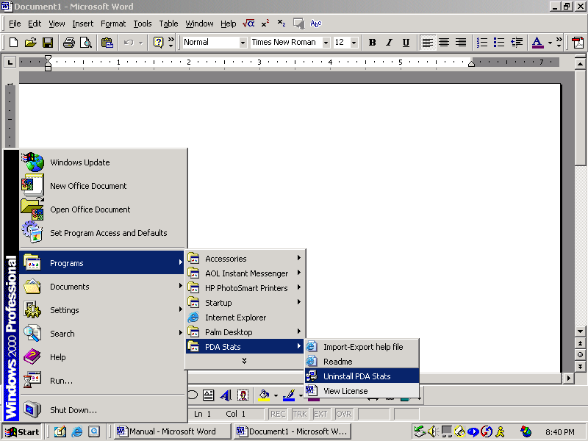
The PDA Stats installation wizard will install PDA Stats V2.7 and the SuperWaba VM onto your Palm OS device.

Steps to Uninstall PDA Stats
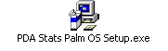
Steps for installing PDA Stats V2.7 onto your Palm OS handheld:

- Double-click on 'PDA_Stats_Palm_OS_Setup.exe' or
'PDA_Stats_Palm_OS_Trial_Version_Setup.exe' to start the installation wizard which installs PDA Stats on you PC as well as your Palm OS device.
- Once the installation wizard completes, PDA Stats will be installed on your handheld the next time it is synchronized.
- Soft reset your handheld. (It is usually a good idea to give your handheld a soft reset after any software installation)

How to Start the Program

There are six main menu options in PDA Stats. These options are initially hidden on the start-up screen (the list editor). By tapping in the heading PDA Stats v2.7, the main menu options will be displayed at the top of the screen.

Each main menu has several submenus, or functions from which to choose. Tap the appropriate submenu item to select a specific routine.

Tap here to see the main menu options.

Starting View of PDA Stats
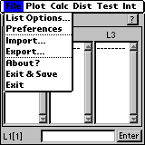

Displayed are the submenu options under the file menu.

Primary Menu Options

Example: Entering the Data

- To enter data into the list editor, tap on the row in the list in which a numerical value is to be stored. This will activate the entry line at the bottom of the screen.

- The cursor will be blinking in the white entry box at the bottom of the screen.

- Tap in the white box and a number pad will be displayed.

- Enter the desired value and click Done.

- The data will be displayed in the white entry box at the bottom of the screen.

- Tap Enter and the data will be displayed in the list.

Note: If you are having trouble doing this or using any of the functions, try using the built-in help feature. To view the help screen, tap the ? in the upper right hand corner of the screen. The help dialog window will be displayed.

Tap here.

Activates the entry line.

Entry Line Display

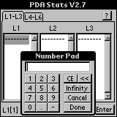

Example of the Number Pad

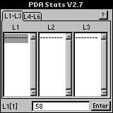

Tap here to see the help screen.

Displaying Help Menu

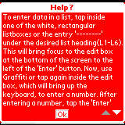

Example of the Help Screen

File:

List Options

- Sort
    - Sort Ascending
Choose the list that is to be sorted. Hit sort. The list is displayed in ascending order.

    - Sort Descending
Choose the list that is to be sorted. Hit sort. The list is displayed in descending order.

- Clear
Choose the list(s) you wish to clear. Hit clear.
Hint: Make sure the correct data is highlighted before hitting clear.

- Insert
Select the list in which data is to be inserted. Tap in the after entry box and enter the desired data.

- Delete
Select the list and entry in which you want to delete data.

- Copy
Select the list in which you want to copy and paste it to the desired list.

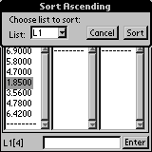

Example of an Ascending Sort

Descending sorts follow the same format.

Unsorted List
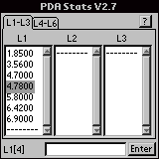

Sorted List
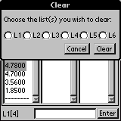

Clearing a List

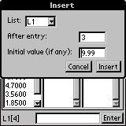

Inserting Additional Data
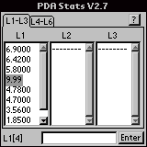

New Data List

Preferences
Allows the display of two to eight digits to the right of the decimal point.

Import
- PDA Stats
Choose the PDA Stats data that is to be imported.

- txt / csv
Choose the .txt or .csv document to be imported.

Export
- PDA Stats
Type desired filename. Type the dataset name. Choose the list(s) that is to be exported. Tap export.

- txt / csv
Type desired filename. Type the dataset name. Choose the list(s) that is to be exported. Choose the appropriate format. Tap export.

About ?
Displays a description of the capabilities of PDA Stats.

Exit & Save
Exits and saves the working file.

Exit
Exits without saving.

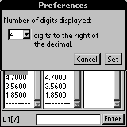

Displaying Decimals

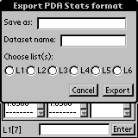

Example of Exporting a File

Importing a file follows the same format.

Export Stats Format

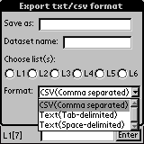

Export txt/csv Format

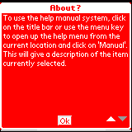

Capabilities Displayed

Remember to
save work!

Plot:

Pie Chart
Allows the data to be displayed in a colorful pie chart. Select the desired list to display the pie chart. An error will occur, if when using the percentage key, the data does not total 100.

Scatter Plot
Allows the data to be displayed as a scatter plot. A scatter plot shows the data as a set of individual points. Choose the x and y lists to be use in plotting. Select the desired mark preference. (rectangle, open circle, or fill circle) Tap the desired window. Window setup will display. Enter the following data: xmin, xmax, xscl, ymin, ymax, and yscl. Tap done to exit window setup. Tap plot. Scatter plot will be displayed.

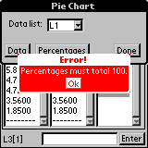
Error occurs when
percentages ≠ 100.

Note: Percentages
must equal 100.

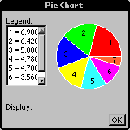

Pie Chart in Varied Colors

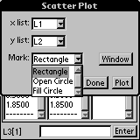

Choosing Mark Preference
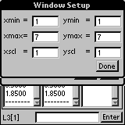

Setting Plot Parameters

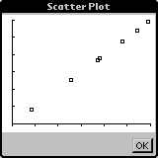

Scatter Plot Display

Line Plot
Allows the data to be displayed as a line graph. Select the x and y lists. Tap window. Window setup will display. Enter the following data: xmin, xmax, xscl, ymin, ymax, and yscl. Tap done to exit window setup. Tap plot. Line graph will be displayed.

Histogram
Allows the data to be displayed as a histogram. A histogram is a series of connecting bars. Select the x list. Tap window. Window setup will display. Enter the following data: xmin, xmax, xscl, ymin, ymax, and yscl. Tap done to exit window setup. Tap plot. Histogram will be displayed.

Bar Chart
Allows the data to be displayed as a bar chart. This options allows for the selection of one or two groups of data. Select choice. If one group is desired, select list 1 and choose the desired list for the data to be displayed in the bar chart. If two groups are desired, select list 1 and choose the desired list for the data and list 2 with the desired data list to be displayed in the bar chart. Tap window. Window setup will display. Enter the following data: ymin, ymax, and yscl. Tap done to exit window setup. Tap plot. Bar chart will be displayed.

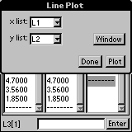

Setting Plot Parameters

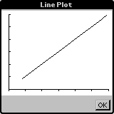

Line Plot Display

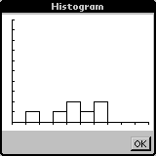

Histogram Display

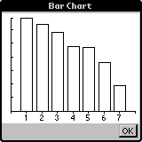

One Group of Data

The bar chart will allow for the selection of one or two groups of data.

Two Groups of Data

Importing a file follows the same format.

Bar Chart Display

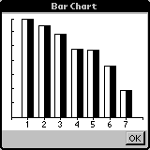

Bar Chart Display

Box Plot
Allows the data to be displayed as a box plot. A box plot displays data in a rectangular fashion over a set of desired values. Choose the x list to be use in plotting. Select the desired type preference. (classic, outliers, or outliers2) Tap the desired window. Window setup will display. Enter the following data: xmin, xmax, and xscl. Tap done to exit window setup. Tap plot. Box plot will be displayed.

Normal Prob Plot
Allows the data to be displayed as a scatter plot. A normal prob plot generates a normal probability for the data in a list. The order statistics from the standard normal distribution are x-coordinates. Choose the y list to be use in plotting. Select the desired mark preference. (rectangle, open circle, or fill circle) Tap the desired window. Window setup will display. Enter the following data: xmin, xmax, xscl, ymin, ymax, and yscl. Tap done to exit window setup. Tap plot. A Normal Prob Plot will be displayed.

Note: A help menu is located in all of the plot menus. Tapping the heading after entering the selected window can access this screen.

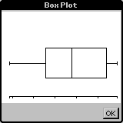

Box Plot Display

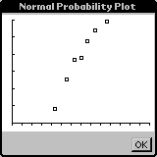

A Normal Probability Plot
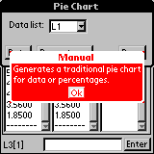

Help is available
on all plot menus.

Calc

1-Var Stats
One-variable statistics computes summary statistics for data in a list. This includes the mean, standard deviation, variance, minimum, maximum, quartiles, and median. Choose the list in which the data is to be calculated. Tap calculate and the data will be displayed. Scroll to see entire list.

2-Var Stats
Two-variable statistics computes summary statistics for two data sets and the correlation coefficient. Choose the two lists to use for calculation. Tap calculate and three tabs will be shown on the toolbar (xdata, ydata, and xydata). Simply tap the tabs to view desired data. Scroll to see entire list.

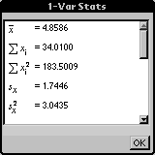

1-Var Stats Functions
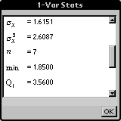

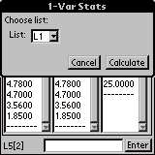

Choose a list and then choose a function.

1-Var Stats Functions
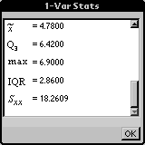

1-Var Stats Functions

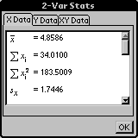

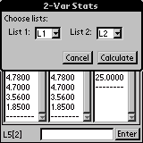

2-Var Stats Functions

Choose a list and then choose a function

2-Var Stats Functions

Regressions
- Linear (a + bx)
This function fits the data to the model y = a + bx using the method of least squares. Select x list, y list that is to be used to find the linear regression. Tap calculate. Linear regression will be displayed. Scroll to see entire list.

- Exponential
This function fits the data to the model y = a b^{x} using the method of least squares on the transformed data x and ln(y). Select x list, y list that is to be used. Tap calculate. Exponential regression will be displayed. Scroll to see entire list.

- Logarithmic
This function fits the data to the model y = a + b ln(x) using the method of least squares on the transformed data ln(x) and y. Select x list, y list that is to be used. Tap calculate. Logarithmic regression will be displayed. Scroll to see entire list.

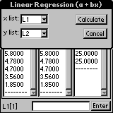

y = a + bx
Example of Choosing a List
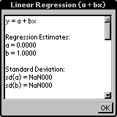

Display of Linear Regression

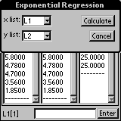

y = a b^{x}
Example of Choosing a List
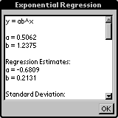

Scroll down for more output.
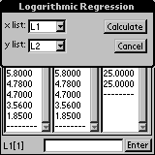

y = a + b ln(x)

Logarithmic Regression Lists

- Power
This function fits the data to the model y = ax^{b} using the method of least squares on the transformed data ln(x) and ln(y). Select x list, y list that is to be used. Tap calculate. Power regression will be displayed. Scroll to see entire list.

- Quadratic
This function fits the data to the second degree polynomial y=ax² + bx + c using the method of least squares. There must be at least three pairs of observations. Select x list, y list that is to be used. Tap calculate. Quadratic regression will be displayed. Scroll to see entire list.

- Cubic
This function fits the data to the polynomial:
y=ax³ + bx² + cx + d
using the method of least squares. There must be at least four pairs of observations. Select x list, y list that is to be used. Tap calculate. Cubic regression will be displayed. Scroll to see entire list

- Quartic
This function fits the data to the polynomial:
y=ax⁴ + bx³ + cx² + dx + e
using the method of least squares. There must be at least five pairs of observations. Select x list, y list that is to be used. Tap calculate. Quartic regression will be displayed. Scroll to see entire list.

- Median-Median
This function fits the data to the model y = a + bx using the median-median line. Select x list, y list that is to be used. Tap calculate. Median-median regression will be displayed. Scroll to see entire list.

- Multiple
This function uses the method of least squares to find the regression equation. Accepts up to five independent variables. Select x list, y list that is to be used. Tap calculate. Multiple regression will be displayed. Scroll to see entire list.

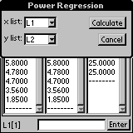

y = a x^{b}

Power Regression Lists
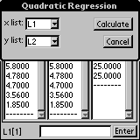

y = ax² + bx + c

Quadratic Regression Lists
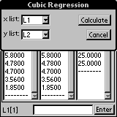

y = ax³+ bx²+cx+d

Cubic Regression Lists
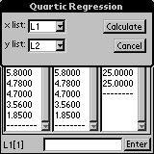

y = ax⁴+ bx³+ cx²+dx+e

Quartic Regression Lists
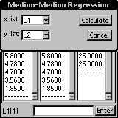

y = a + bx

Median-Median Regression
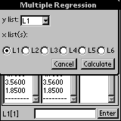

Accepts up to 5 independent variables.

Multiple Regression

Probability
- Permutations
Returns the number of permutations of n objects taken r at a time. Tap in the n box and a number pad will display. Type the desired number and tap done. The number will be displayed in the box. Tap in the r box and a number pad will display. Type the desired number and tap done. The number will be displayed in the box. Tap calculate. The answer will be displayed next to nPr.

- Combinations
Returns the number of combinations of n objects taken r at a time. Tap in the n box and a number pad will display. Type the desired number and tap done. The number will be displayed in the box. Tap in the r box and a number pad will display. Type the desired number and tap done. The number will be displayed in the box. Tap calculate. The answer will be displayed next to nCr.

- Factorial!
This calculates n! = n(n-1)…(3)(2)(1). Tap in the n box and a number pad will display. Type the desired number and tap done. The number will be displayed in the box. Tap calculate. The answer will be displayed next to n!.

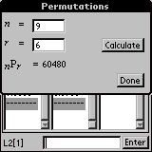

n P r

Choose n and r.
Calculate permutation.

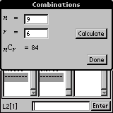

n C r

Choose n and r.
Calculate combination.

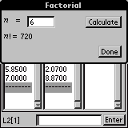

n!

Choose n and r.
Calculate factorial.

- Random Integer
This generates n random integers between a and b, with or without replacement, and stores the values in a list. Tap in the a box and a number pad will display. Type the desired number and tap done. The number will be displayed in the box. Tap in the b box and a number pad will display. Type the desired number and tap done. The number will be displayed in the box. Tap in the n box and a number pad will display. Type the desired number and tap done. The number will be displayed in the box. Select the list that will store the data. Check the box for replacement, if desired. Tap generate. A box will appear that will display finished. Tap done. Answer will be displayed in selected list.

- Random Normal
This will generate n random numbers from a normal distribution with mean mu ($μ$) and standard deviation sigma ($σ$). Tap in the $μ$ box and a number pad will display. Type the desired number and tap done. The number will be displayed in the box. Tap in the $σ$ box and a number pad will display. Type the desired number and tap done. The number will be displayed in the box. Tap in the n box and a number pad will display. Type the desired number and tap done. The number will be displayed in the box. Select the list that will store the data. Tap generate. A box will appear that will display finished. Tap done. Answer will be displayed in selected list.

- Random Binomial
This will generate m random numbers from a binomial distribution with n trials and probability of success p. Tap in the n box and a number pad will display. Type the desired number and tap done. The number will be displayed in the box. Tap in the p box and a number pad will display. Type the desired number and tap done. The number will be displayed in the box. Tap in the m box and a number pad will display. Type the desired number and tap done. The number will be displayed in the box. Select the list that will store the data. Tap generate. A box will appear that will display finished. Tap done. Answer will be displayed in selected list.
Note: Incorrect data will cause an error message to be displayed.

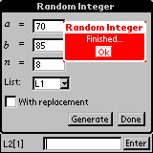

Random Integer Display

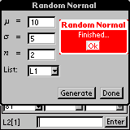

Important: Enter Correct Data.

Random Normal Display

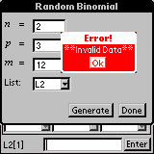

Incorrect Data Error

- Random Sample
Generates n random numbers from a sample contained in a list, with or without replacement. Select the input list and output list. Tap in the n box and a number pad will display. Type the desired number and tap done. The number will be displayed in the box. Select the list that will store the data. Check the box for replacement, if desired. Tap generate. A box will appear that will display finished. Tap done. Answer will be displayed in selected list.

- Random (0,1)
This generates n random numbers between 0 and 1, and stores the values in a list. Tap in the n box and a number pad will display. Type the desired number and tap done. The number will be displayed in the box. Select the list that will store the data. Tap generate. A box will appear that will display finished. Tap done. Answer will be displayed in selected list.

- Random Seed
This sets the random number seed. Tap in the seed value box and a number pad will display. Type the desired number and tap done. The number will be displayed in the box. Tap set. A box will display random seed set. Tap ok. Answer will be displayed in selected list.

CorrMat
This displays the correlation matrix. This computes the correlation between all possible pairs of the selected lists. Choose the list(s). Tap calculate. The correlation matrix will appear.

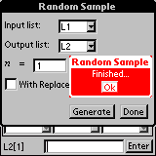

Generating Random Numbers
Random Sample Display

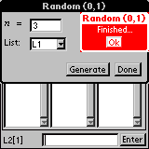

Random Numbers ( 0 – 1)

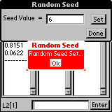

Finding a Random Seed
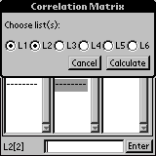

Correlation Matrix Lists

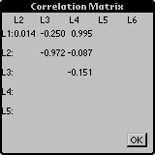

Correlation Matrix Results

Dist

Inverse
- Inverse Normal
This is the inverse cumulative probability function for a normal random variable. Let X be a normal random variable with mean mu ($μ$) and standard deviation sigma ($σ$). For a given probability p, this function returns an x such that, P(X<=x)=p. Tap in the p box and a number pad will display. Type the desired number and tap done. The number will be displayed in the box. Tap in the $μ$ box and a number pad will display. Type the desired number and tap done. The number will be displayed in the box. Tap in the $σ$ box and a number pad will display. Type the desired number and tap done. The number will be displayed in the box. Tap calculate. A box will appear that will display finished. Tap done. Answer will be displayed next to x on the screen.

- Inverse t
This is the inverse cumulative probability function for a t random variable. Let X have a t distribution with v degrees of freedom. For a given probability p, this function returns an x such that, P(X<=x)=p. Tap in the p box and a number pad will display. Type the desired number and tap done. The number will be displayed in the box. Tap in the v box and a number pad will display. Type the desired number and tap done. The number will be displayed in the box. Tap calculate. A box will appear that will display finished. Tap done. Answer will be displayed next to x on the screen.

- Inverse Chi-square
This is the inverse cumulative probability function for a chi-square random variable. Let X have a chi-square distribution with v degrees of freedom. For a given probability p, this function returns an x such that, P(X<=x)=p. Tap in the p box and a number pad will display. Type the desired number and tap done. The number will be displayed in the box. Tap in the v box and a number pad will display. Type the desired number and tap done. The number will be displayed in the box. Tap calculate. A box will appear that will display finished. Tap done. Answer will be displayed next to x on the screen.

Inverse Cumulative Probability Functions

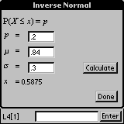

Inverse Normal Display

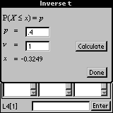

Inverse t Display

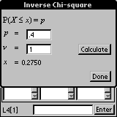

Inverse Chi-square Display

- Inverse F
This is the inverse cumulative probability function for a F random variable. Let X have a F distribution with v1 and v2 degrees of freedom. For a given probability p, this function returns an x such that, P(X<=x)=p. Tap in the p box and a number pad will display. Type the desired number and tap done. The number will be displayed in the box. Tap in the v1 box and a number pad will display. Type the desired number and tap done. The number will be displayed in the box. Tap in the v2 box and a number pad will display. Type the desired number and tap done. The number will be displayed in the box. Tap calculate. A box will appear that will display finished. Tap done. Answer will be displayed next to x on the screen.

Discrete
All divisions in this discrete category have the possibility of choosing pdf (probability distribution function) or cdf (cumulative distribution function) after the desired function is chosen. Although each is somewhat different, you may choose them just the same.
pdf returns the function P(X=x).
This function is the probability of x successes.
cdf returns the function P(a ≤ X ≤ b).
This function returns the probability that X takes on a value between a and b (inclusive).

- Binomial
Let X be a binomial random variable where n is the number of trials and p is the probability of success. Tap in boxes with the desired data. Tap calculate and the answer will appear on the screen.
  - pdf
  - cdf

- Negative Binomial
Let X be a negative binomial random variable where p is the probability of success. Tap in boxes with the desired data. Tap calculate and the answer will appear on the screen.
  - pdf
  - cdf

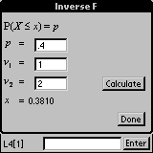

Inverse F Display

Binomial Random Variables

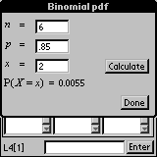

Binomial Random Variable

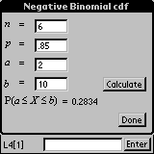

Negative Binomial Random

- Poisson
Let X be a poisson random variable with mean lambda ($λ$) where p is the probability of success. Tap in boxes with the desired data. Tap calculate and the answer will appear on the screen.
  - pdf
  - cdf

- Geometric
Let X be a geometric random variable with probability of success, p. Tap in boxes with the desired data. Tap calculate and the answer will appear on the screen.
  - pdf
  - cdf

- HyperGeometric
Let X be a hypergeometric random variable with finite population size N, M successes, and N trials. Tap in boxes with the desired data. Tap calculate and the answer will appear on the screen.
  - pdf
  - cdf

Continuous
All divisions in this discrete category have the possibility of choosing pdf (probability distribution function) or cdf (cumulative distribution function) after the desired function is chosen. Although each is somewhat different, you may choose them just the same.
pdf returns the function f(x).
This function returns the pdf evaluated at x.
cdf returns the function P(a ≤ X ≤ b).
This function returns the probability that X takes on a value between a and b.

- Normal
Let X be a normal random variable with mean mu ($μ$) and standard deviation sigma ($σ$). Tap in boxes with the desired data. Tap calculate and the answer will appear on the screen.
  - pdf
  - cdf

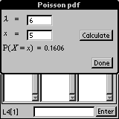

Poisson Random Variable

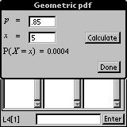

Geometric Random Variable

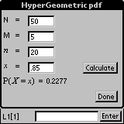

HyperGeometric
Random Variable

Continuous Function
pdf
cdf

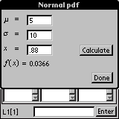

Normal Continuous
Random Variable

- t
Let X be a normal random variable having t distribution and v degrees of freedom. Tap in boxes with the desired data. Tap calculate and the answer will appear on the screen.
  - pdf
  - cdf

- Chi-square
Let X be a chi-square random variable with v degrees of freedom. Tap in boxes with the desired data. Tap calculate and the answer will appear on the screen.
  - pdf
  - cdf

- F
Let X be a F random variable with v1 and v2 degrees of freedom. Tap in boxes with the desired data. Tap calculate and the answer will appear on the screen.
  - pdf
  - cdf

- Exponential
Let X be a exponential random variable with parameter lambda ($λ$). Tap in boxes with the desired data. Tap calculate and the answer will appear on the screen.
  - pdf
  - cdf

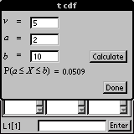

t Distribution Display

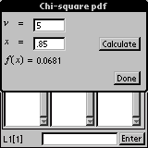

Chi-square Random Variable
v Degree(s) of Freedom

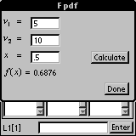

F Random Variable

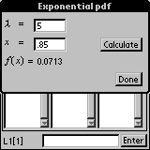

Exponential Random Variable

- Gamma
Let X be a gamma random variable with parameters alpha ($α$) and beta ($β$). Tap in boxes with the desired data. Tap calculate and the answer will appear on the screen.
  - pdf
  - cdf

- Weibull
Let X be a Weibull random variable with parameters alpha ($α$) and beta ($β$). Tap in boxes with the desired data. Tap calculate and the answer will appear on the screen.
  - pdf
  - cdf

- LogNormal
Let X be a lognormal random variable with parameters mu ($μ$) and sigma ($σ$). Tap in boxes with the desired data. Tap calculate and the answer will appear on the screen.
  - Pdf
  - cdf

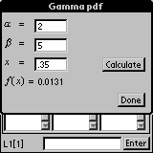

Gamma Random Variable
Random Variable with Parameters alpha ($α$) and beta ($β$)

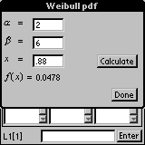

Weibull Random Variable

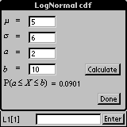

LogNormal Random Variable

Test

Z-Tests
- 1-Sample
A large sample hypothesis test on a population mean: Input either data in a list or summary statistics. Output includes the computed z statistic and the p value. Choose input method: Stats or data, tap ok. Tap in the desired box and a number pad will appear. Enter appropriate data. Tap calculate and the z and p values will appear. Tap the draw button to generate a graph.

- 2-Sample
A large sample hypothesis test for comparing two population means: Input either data in lists or summary statistics. Output includes the computed z statistics and the p value. Choose input method: Stats or data, tap ok. Tap in the desired box and a number pad will appear. Enter appropriate data. Tap calculate and the z and p values will appear. Tap the draw button to generate a graph.

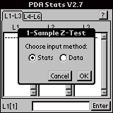
Choose input method.

1 Sample Z-Test
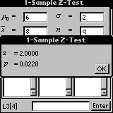

1-Sample Z-Test

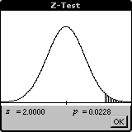

Graph of 1-Sample Z-Test
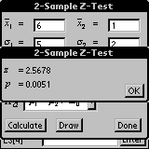

Tap the draw button to generate a graph.

2-Sample Z-Test
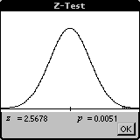

Graph of 2-Sample Z-Test

t-Tests
- 1-Sample
A small sample hypothesis test on a population mean: Input either data in a list or summary statistics. Output includes the computed t statistic and the p value. Choose input method: Stats or data, tap ok. Tap in the desired box and a number pad will appear. Enter appropriate data. Tap calculate and the t and p values will appear. Tap the draw button to generate a graph.

- 2-Sample
A small sample hypothesis test for comparing two population means: Input either data in a list or summary statistics. Output includes the computed t statistic and the p value. Choose input method: Stats or data, tap ok. Tap in the desired box and a number pad will appear. Enter appropriate data. Tap calculate and the t and p values will appear. Tap the draw button to generate a graph.

- Paired
A paired t test: Input either paired data in lists or summary statistics. Output includes the computed t statistic and the p value. Choose input method: Stats or data, tap ok. Tap in the desired box and a number pad will appear. Enter appropriate data. Tap calculate and the t and p values will appear. Tap the draw button to generate a graph.

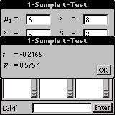

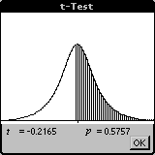 1-Sample t-Test

Graphic Output of
t-Test

Graph of 1-Sample t-Test

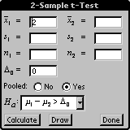

2-Sample t-Test

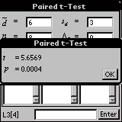

Paired t-Test

Proportion
- 1-Sample
A one-sample hypothesis test on a population proportion: Input the number of successes, number of trials, and the hypothesized value pO. Output includes the computed z statistic and the p value. Tap in the desired box and a number pad will appear. Enter appropriate data. Tap calculate and the t and p values will appear. Tap the draw button to generate a graph.

- 2-Sample
A two-sample hypothesis test for comparing population proportions: Input the number of successes, size of each sample, and the hypothesized difference. Output includes the computed z statistic and the p value. Tap in the desired box and a number pad will appear. Enter appropriate data. Tap calculate and the t and p values will appear. Tap the draw button to generate a graph.

Variance
- Chi-square
A hypothesis test on a population variance: Input either data in a list or summary statistics. Output includes the computed chi-square statistic and the p value. Choose input method: Stats or data, tap ok. Tap in the desired box and a number pad will appear. Enter appropriate data. Tap calculate and the t and p values will appear. Tap the draw button to generate a graph.

- F Test
A hypothesis test for comparing two population variances: Input either data from lists or summary statistics. Output includes the computed F statistic and the p value. Choose input method: Stats or data, tap ok. Tap in the desired box and a number pad will appear. Enter appropriate data. Tap calculate and the t and p values will appear. Tap the draw button to generate a graph.

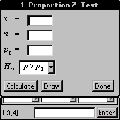

Proportion Hypothesis Tests
1-Sample Proportion

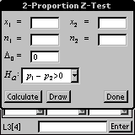

2-Sample Proportion

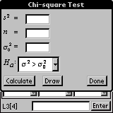

Chi-square Variance

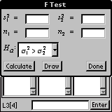

F Test Variance

Chi-square GOF
A chi-square goodness-of-fit test: Input a list of observed values and a list of expected values. Output included the computed chi-square statistic and the p value. Select the data to be computed. Tap calculate to see the computed answer. Tap the draw button to generate a graph.

Chi-square 2-way
Chi-square test for independence: Input a two-way contingency table. Output includes the expected values, cell computations, computed chi-square statistic and the p value. The button labeled ‘*’ clears all values from the tables. Choose the matrix from the drop-down lists: observations, expected or computation. A matrix editor will appear. Enter the dimensions: rows and columns, by tapping in the box and a number pad will appear. Tap construct and the empty boxes for the matrix will appear. Tap in the boxes to enter data. Tap calculate and the computed answer will appear. Tap draw and a graph will be generated.

ANOVA
A one-way analysis of variance: Input either data from lists or summary statistics. Output is the analysis of a variance table. Choose input method: Stats or data, also select the number of groups. Tap in the desired boxes and a number pad will appear. Enter appropriate data. Tap calculate and the data will appear.

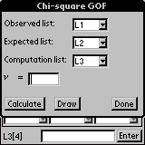

Chi-square GOF
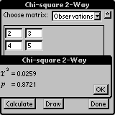

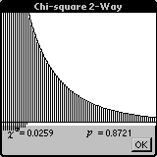 Chi-square 2-way

Chi-square
2-way Graph

Graph of Chi-square 2-way

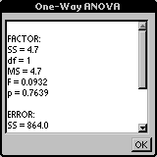

1-way ANOVA
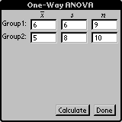

1-way ANOVA

ANOVA 2-way
A two-way analysis of variance: Input three lists: observations, levels of factor 1, and levels of factor 2. Output is the analysis of a variance table. Choose the appropriate lists. Tap calculate and the data will appear.

Nonparametrics
- SignTest
A sign test based on the binomial distribution: Input is either data or summary statistics, hypothesized value of a median, and the alternative hypothesis. Output includes the computed test statistic and the p value. Choose input method: Stats or data, tap ok. Tap in the desired box and a number pad will appear. Enter appropriate data. Tap calculate and the data will appear.

- Wilcoxon
  - 1-Sample
A Wilcoxon signed-rank test, one– and two- sample, based on the data or summary statistics: Output includes the test statistic and the p value based on the normal approximation. Choose input method: Stats or data, tap ok. Tap in the desired box and a number pad will appear. Enter appropriate data. Tap calculate and data will appear.

  - 2-Sample
A Wilcoxon signed-rank test, one– and two- sample, based on the data or summary statistics: Output includes the test statistic and the p value based on the normal approximation. Choose input method: Stats or data, tap ok. Tap in the desired box and a number pad will appear. Enter appropriate data. Tap calculate and the data will appear.

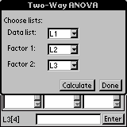

2-way ANOVA

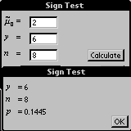

Sign Test on the
Binomial Distribution

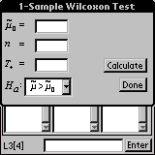

Wilcoxon Signed-rank Test
Wilcoxon 1-Sample Display

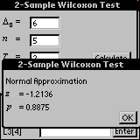

Wilcoxon 2-Sample Display

- Mann-Whitney
A Mann-Whitney test for a difference in population medians: Output includes the test statistic and the p value based on the normal approximation. Choose the appropriate list. Enter appropriate data. Tap calculate and the data will appear.

- Kruskal-Wallis
A Kruskal-Wallis test for an identical population: Output includes the test statistic and the p value based on a chi-square distribution. Choose the appropriate lists. Tap calculate and the data will appear.

- Friedman
A Friedman test for a randomized block design: Output includes the value of the test statistic and the p value based on a chi-square distribution. Choose the appropriate lists: data, treatments, blocks. Tap calculate and the data will appear.

- Runs
A Runs test determines if a sequence is random. Output includes the test statistic and the p value based on the normal approximation. Choose input method: Stats or data, tap ok. Tap in the desired box and a number pad will appear. Enter appropriate data. Tap calculate and the data will appear.

- Spearman
A Spearman test computes the Spearman rank correlation coefficient, the nonparametric equivalent to the traditional correlation coefficient. Choose the appropriate lists. Tap calculate and the data will appear

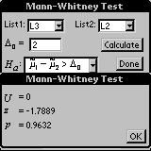

Choose desired list.
Mann-Whitney Test
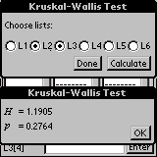

Kruskal-Wallis Test

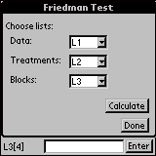

Friedman Test
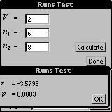

Runs Test

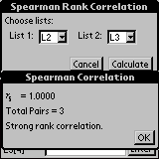

Spearman Test

Int

Z-Intervals
- 1-Sample
A large-sample confidence interval for a population mean: Input either data in a list or summary statistic. Output includes the z critical value and the confidence interval. Choose input method: Stats or data, tap ok. Tap in the desired box and a number pad will appear. Enter appropriate data. Tap calculate and data will appear.

- 2-Sample
A large-sample confidence interval for the difference between two population means: Input either data in lists or summary statistics. Output includes the z critical value and the confidence interval. Choose input method: Stats or data, tap ok. Tap in the desired box and a number pad will appear. Enter appropriate data. Tap calculate and data will appear.
Note: Incorrect data will cause an error message to be displayed.

t-Intervals
- 1-Sample
A small-sample confidence interval for a population mean: Input either data in a list or summary statistic. Output includes the t critical value and the confidence interval. Choose input method: Stats or data, tap ok. Tap in the desired box and a number pad will appear. Enter appropriate data. Tap calculate and data will appear.

- 2-Sample
A small-sample confidence interval for the difference between two population means: Input either data in lists or summary statistics. Output includes the t critical value and the confidence interval. Choose input method: Stats or data, tap ok. Tap in the desired box and a number pad will appear. Enter appropriate data. Tap calculate and data will appear.

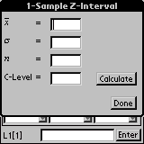

1-Sample Z-Interval

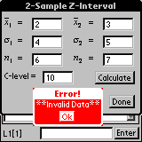
Important: Enter correct data.

2-Sample Z-Interval

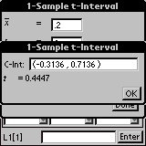

1-Sample t-Interval

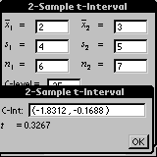

2-Sample t-Interval

Proportion
- 1-Sample
A confidence interval for a population proportion: Input the number of successes, number of trials, and the confidence level. Output includes the sample proportion, the z critical value and the confidence interval. Tap in the desired box and a number pad will appear. Enter appropriate data. Tap calculate and data will appear.

- 2-Sample
A confidence interval for the difference between two population proportions: Input the number of successes, number of trials, and the confidence level. Output includes the sample proportion, the z critical value and the confidence interval. Tap in the desired box and a number pad will appear. Enter appropriate data. Tap calculate and data will appear.

Variance
- Chi-square
A confidence interval for a population variance using the chi-square distribution: Input either data in a list or summary statistic. Output includes two chi-square critical values and the confidence interval. Choose input method: Stats or data, tap ok. Tap in the desired box and a number pad will appear. Enter appropriate data. Tap calculate and data will appear.

- F Interval
A confidence interval for the ratio of two population variances using the F distribution: Input either data from lists or summary statistics. Output includes two F critical values and the confidence interval. Choose input method: Stats or data, tap ok. Tap in the desired box and a number pad will appear. Enter appropriate data. Tap calculate and data will appear.

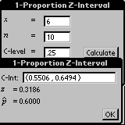

Confidence Interval for Population Proportions

1-Sample Proportion
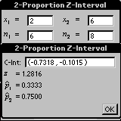

2-Sample Proportion

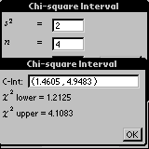

Chi-square Variance

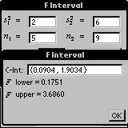

F Interval Display

