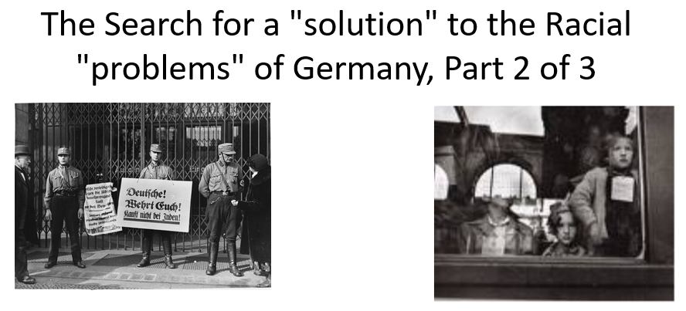

Best practices for making and using notes?
- Write them down, do not just type them up.
- Do not try to record verbatim.
- Review the content by first attempting to answer the essential question defining the lecture, and then make yourself aware of what you do not remember, questions that you have.
- Review notes for related lectures.
- Create a timeline of events to develop awareness of sequence of events and their significance to the lecture goals.

Three Essential Questions to Ponder:

- How to interpret or place in context persecution before 1939?
- How should we interpret events between 1939 and 1941? (focus of part 2)
- When was a decision made to kill European Jews? (this will be answered in a separate series)
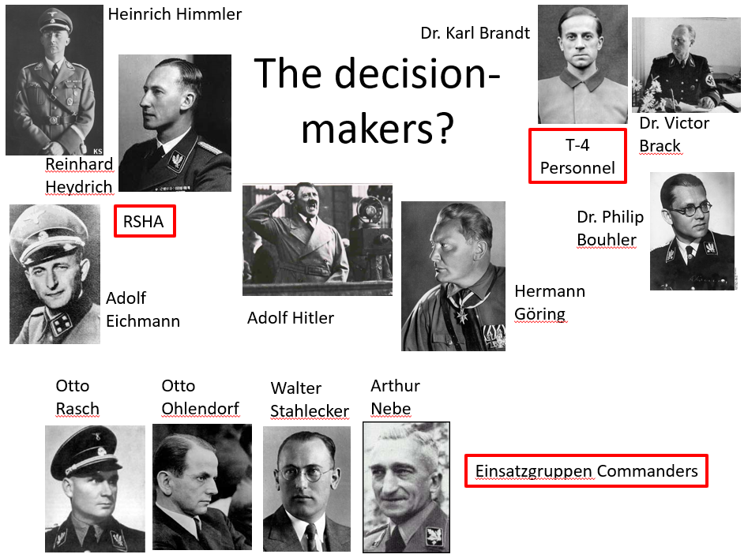
In part 3 of The Search for a Solution, Dr. Stallbaumer will offer her interpretation of events between 1939 and 1941. What is her thesis? What evidence does she use in this lecture to support her interpretations? Is she plausible?

Terminology to familiarize yourself with (and locate on a map when relevant; see maps below):
- Pre-Auschwitz Context
- Volksdeutsche
- VoMi = Hauptamt Volksdeutsche Mittelstelle
- Lublin Reservation
- Madagascar Plan
- General Government of Poland
- Ghettoization
- Endziel
- Judenrat (plural Judenräte)
- “attritionists”
- “productionists”

What are the Resettlement Plans? Why does Dr. Stallbaumer believe that resettlement is still pointing to a territorial “solution”?

What are the standards of history? How do you advance a plausible historical interpretation when we lack evidence? Why are some interpretations more plausible than others?

