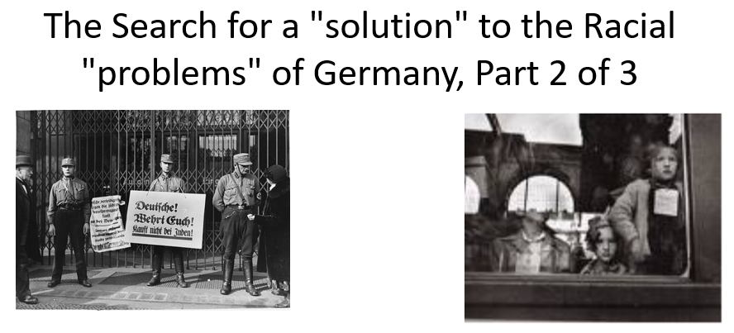

Best practices for making and using notes?
- Write them down, do not just type them up.
- Do not try to record verbatim.
- Review the content by first attempting to answer the essential question defining the lecture, and then make yourself aware of what you do not remember, questions that you have.
- Review notes for related lectures.
- Create a timeline of events to develop awareness of sequence of events and their significance to the lecture goals.

Three Essential Questions to Ponder:

- How to interpret or place in context persecution before 1939?
- How should we interpret events between 1939 and 1941? (focus of part 2)
- When was a decision made to kill European Jews?

Review: What is Dr. Stallbaumer’s interpretation of persecution before 1939? What evidence does she use in the lecture to support her interpretations? Is she plausible?

What is the difference between how an intentionalist and a functionalist interpret the origins of the Holocaust?

If we would see the schools on a spectrum, where might you lean? And more importantly, why?

Intentionalists --------------------------------------------------------------------- Functionalists

Make notes on how each of these individuals or groups may have been involved in the decision-making:
