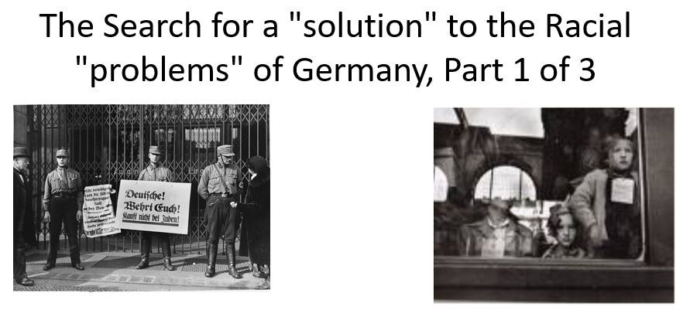

Best practices for making and using notes?
- Write them down, do not just type them up.
- Do not try to record verbatim.
- Review the content by first attempting to answer the essential question defining the lecture, and then make yourself aware of what you do not remember, questions that you have.
- Review notes for related lectures.
- Create a timeline of events to develop awareness of sequence of events and their significance to the lecture goals.

Three Essential Questions to Ponder:

- How to interpret or place in context persecution before 1939? (focus of part 1)
- How should we interpret events between 1939 and 1941?
- When was a decision made to kill European Jews?
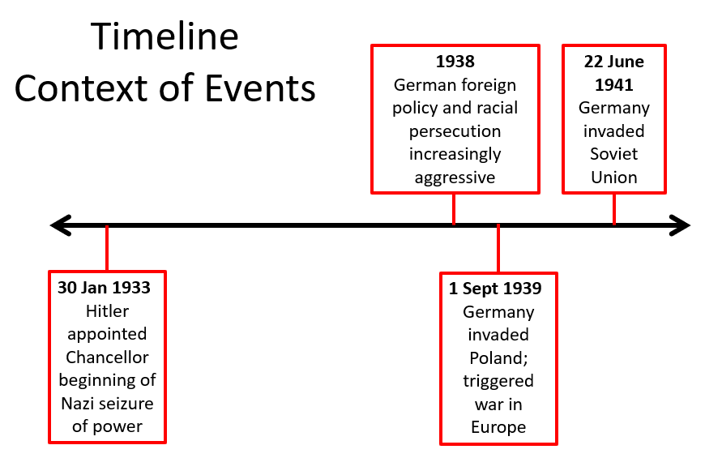

What is Dr. Stallbaumer’s interpretation of persecution before 1939? What evidence does she use in the lecture to support her interpretations? Is she plausible?

Be able to recognize and how each of these contribute to a racial state (by the way, we could easily say system or systemic racism)?

- Media Blitzkrieg (Claudia Koonz)
- Nazi Party Harassment
- Reich-level Decrees
- Police Actions
- Other Actions
- Administrative Fiat

