Best practices for making and using notes?
- Write them down, do not just type them up.
- Do not try to record verbatim.
- Review the content by first attempting to answer the essential question defining the lecture, and then make yourself aware of what you do not remember, questions that you have.
- Review notes for related lectures.
- Create a timeline of events to develop awareness of sequence of events and their significance to the lecture goals.

Essential Questions to Ponder as you observe the video clips:
- What do you discover about the Holocaust from these video clips?
- What factors influence video testimony?
- What do readers or audiences hope to achieve when reading or hearing the voices of survivors?
- What is the distinction between “selfish” and “self-ish” acts described by Lawrence Langer? What does he mean by the “impromptu self”? How might we use these concepts to understand Jewish survivor experiences?

Surviving the Killing Squads – Rivka’s Story
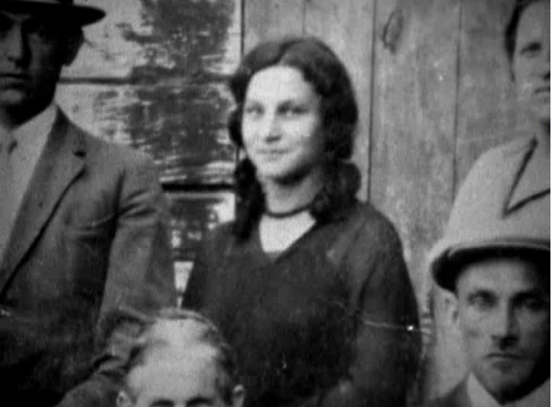
Arrival at Auschwitz
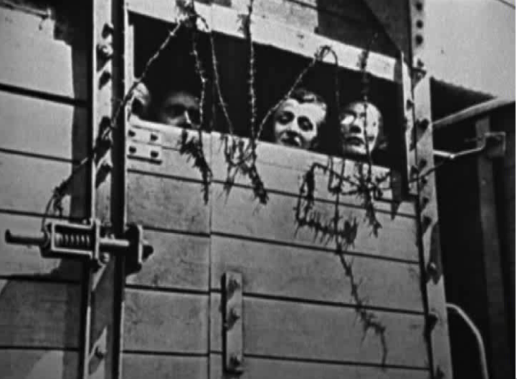
De-individuation: A Number

