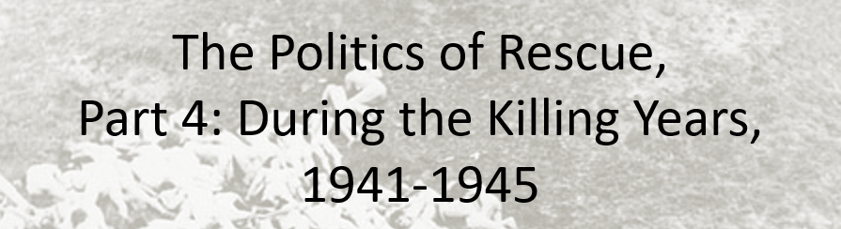

Best practices for making and using notes?
- Write them down, do not just type them up.
- Do not try to record verbatim.
- Review the content by first attempting to answer the essential question defining the lecture, and then make yourself aware of what you do not remember, questions that you have.
- Review notes for related lectures.
- Create a timeline of events to develop awareness of sequence of events and their significance to the lecture goals.

Essential Questions to Ponder in this series of lectures:
- What is counterfactual history and how do we use it to explore the past?
- Was rescue or aid possible?
- Did the United States engage in rescue activities or provide more aid than it did? Why or Why not?
- Could the United States have done more to rescue Jews? Was there a public moral or ethical obligation?
- What lessons, if any, can we draw from contemplating the problem of rescue?

Context Warning: As of 17 December 1942, the US Government and its Allies acknowledged systematic extermination of European Jews. During 1943, the tide of war moves in the favor of the Allies, and by this time, 80% of Jews were murdered. During 1943-1944, Germany’s relations with its allies, Italy, Romania, and Hungary changed, which altered the status of Jews living in these countries. Most other Jews under German control were located in ghettos or concentration camps.

Names of Individuals:
Henry Morgenthau, Secretary of Treasury
John J. McCloy, Secretary of War
John W. Pehle, Director, War Refugee Board

What was the American public’s and US Government response to the Allied Joint Declaration of 17 December 1942?

What was the Bermuda Conference? What did it reveal about the US Government commitment to the aid or rescue of European Jews?

What facts or evidence support an interpretation that more could have been done to aid or rescue Jews?

Topics Explored in this Lecture | Your Notes:
Ransom
Transportation to Safe Havens
False papers & bribery
Bombing Auschwitz
Retaliatory Bombing
War Refugee Board

Document Excerpts | Your notes:
