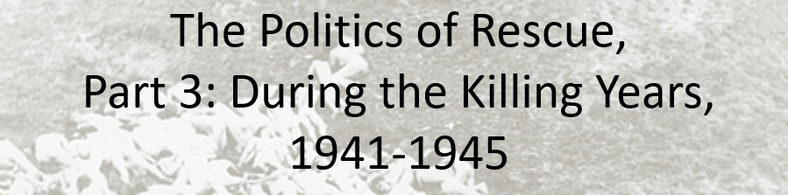

Best practices for making and using notes?
- Write them down, do not just type them up.
- Do not try to record verbatim.
- Review the content by first attempting to answer the essential question defining the lecture, and then make yourself aware of what you do not remember, questions that you have.
- Review notes for related lectures.
- Create a timeline of events to develop awareness of sequence of events and their significance to the lecture goals.

Essential Questions to Ponder in this series of lectures:
- What is counterfactual history and how do we use it to explore the past?
- Was rescue or aid possible?
- Did the United States engage in rescue activities or provide more aid than it did? Why or Why not?
- Could the United States have done more to rescue Jews? Was there a public moral or ethical obligation?
- What lessons, if any, can we draw from contemplating the problem of rescue?

Context Warning: Polish and Soviet Jews were massacred in increasing large numbers after Germany invaded the eastern Poland and the USSR. At what point it became systematic is debated by historians, and your interpretation of the origins of the “final solution” needs to be taken into account. The US entered the war in December 1941, which fundamentally changed the context in which it operated.

Names of individuals:
Rabbi Stephen Wise
Gerhart Riegner

What activities might rescue have included?

What were the challenges faces and obstacles to aid or rescue Jews?

- Knowing and Understanding
- 1941 news
- December 1941

Military Attaché’s Study of War Propaganda, Survey of 20 Americans, 6 March 1942

“Anti-Semitism has become firmly implanted in Germany and many of the occupied areas. It is therefore inadvisable for Jews to be in conspicuous positions in directing United Nations propaganda or to use them in the preparation or delivery of material which would reveal their race. For the same reason, it is also deemed inadvisable to defend or champion the Jewish cause vigorously. … If real atrocities occur they should be revealed, but the evidence and proof should be so convincing that there should be no doubt as to their authenticity. In general, I believe it would be better to ignore the atrocity idea because it became quite generally discredited as a result of world war [I] practices.”
Your notes:

Evidence that the US State Department most likely engaged in obstructionism in August-September 1942 is presented as turning point. Does the evidence support an interpretation of obstructionism?

Select Documents | Your notes and Interpretation:
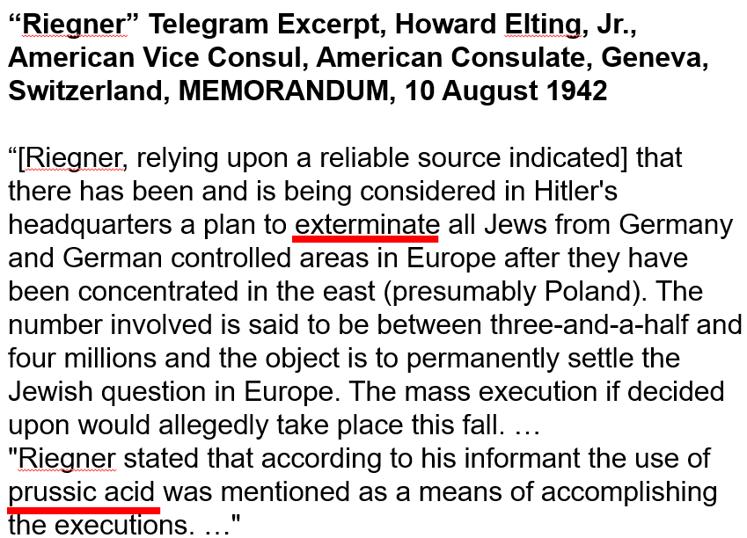
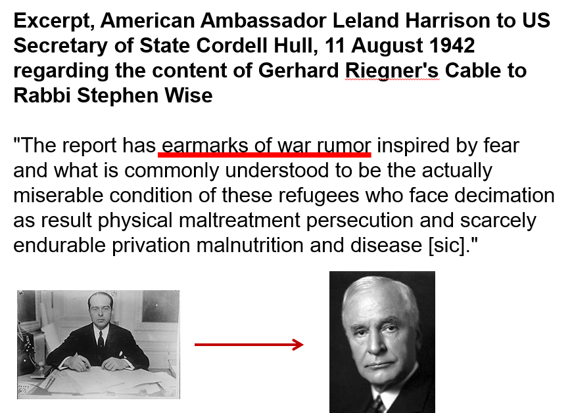
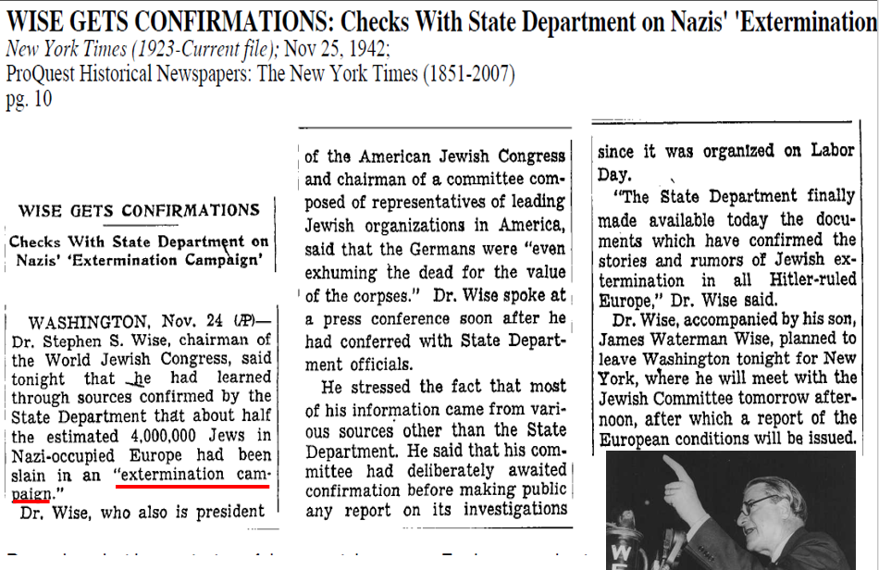

Joint Allied Declaration, 17 December 1942

First Paragraph of 17 December 1942 Joint Allied Declaration

"The attention of the Belgian, Czechoslovak, Greek, Luxembourg Netherlands, Norwegian, Polish, Soviet, United Kingdom, United States, and Yugoslav Governments and also of the French National Committee has been drawn to numerous reports from Europe that the German authorities, not content with denying to persons of Jewish race in all the territories over which their barbarous rule has been extended, the most elementary human rights, are now carrying into effect Hitler's oft-repeated intention to exterminate the Jewish people in Europe."

Your notes:

