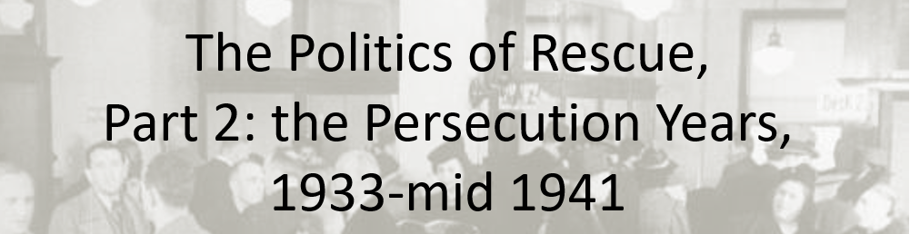

Best practices for making and using notes?
- Write them down, do not just type them up.
- Do not try to record verbatim.
- Review the content by first attempting to answer the essential question defining the lecture, and then make yourself aware of what you do not remember, questions that you have.
- Review notes for related lectures.
- Create a timeline of events to develop awareness of sequence of events and their significance to the lecture goals.

Essential Questions to Ponder in this series of lectures:
- What is counterfactual history and how do we use it to explore the past?
- Was rescue or aid possible?
- Did the United States engage in rescue activities or provide more aid than it did? Why or Why not?
- Could the United States have done more to rescue Jews? Was there a public moral or ethical obligation?
- What lessons, if any, can we draw from contemplating the problem of rescue?

Context Warning: Jews were being persecuted, so from the perspective of the United States Government, the issue at hand before 1941 is immigration or aid from persecution, not aid or rescue from extermination.

Terminology to familiarize yourself with:
Nativism
Racism
Xenophobia
LPC Clause – Likely to become a public charge
Visa Division – Department of State

Individuals to make note:
George Messersmith
Franklin D. Roosevelt
Breckinridge Long

What do public opinion polls reveal about the presence of nativism and racism in the United States? How might public opinion impact US government policy?

What were the immigration laws? How did they limit the entry of Jewish refugees into the United States from 1933 through at least 1945?

In these two charts from lecture, I offer explanations for the numbers. Make notes to make sense of the numbers. Do the immigration quotas suggest that the US government could have done more to help refugees? Does the evidence suggest that the US State Department was engaging in obstructionism? If so, when?

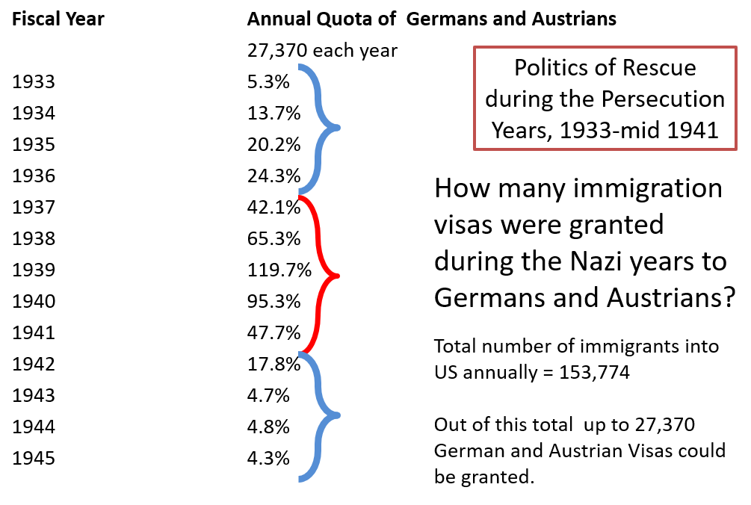 | 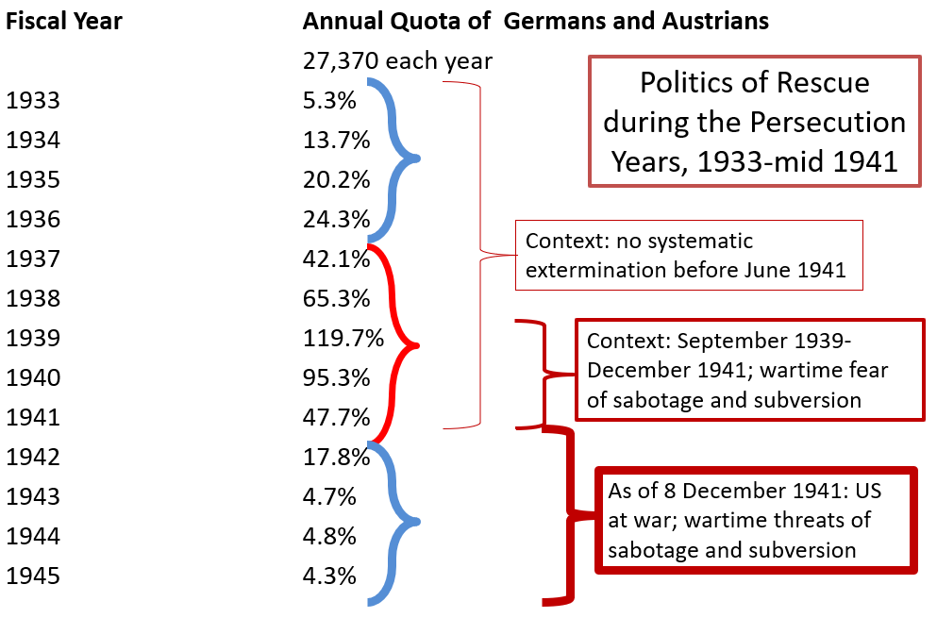
Your notes:

How do you interpret this document excerpt: George Messersmith, Foreign Consul in Vienna, 13 November 1936:

“Stated briefly, it is to preserve our liberal attitude on immigration and yet at the same time adequately protect the interests of our country and people. The object is not, as some interpret it, to maintain the United States as an asylum or refuge for dissatisfied and oppressed people in other parts of the world irrespective of their capacity to become good and self-supporting citizens of our country. Their object is also not, as some interpret it, to keep out certain classes of persons on account of the race, religion, or political ideas.”
Your notes:

What were the economic restrictions placed on Jews who wanted to leave Germany?

When war broke out in Europe in 1939, how did that impact the U.S. Department of State’s approach to helping refugees?

How do you interpret this document excerpt: Breckenridge Long, June 1940, State Department, Visa Division, Memo

“We can delay and effectively stop for a temporary period of indefinite length the number of immigrants into the United States. We could do this by simply advising our consuls, to put every obstacle in the way and to require additional evidence and to resort to various administrative devices which would postpone and postpone and postpone the granting of the visas. … emphasis must be placed on the fact that discrimination must not be practiced ….”
Your notes:

