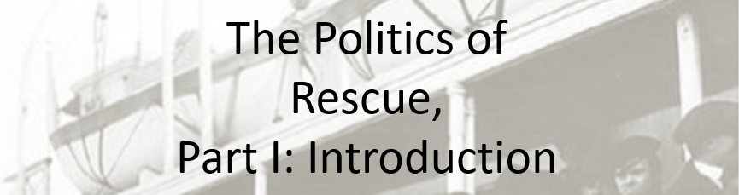

Best practices for making and using notes?
- Write them down, do not just type them up.
- Do not try to record verbatim.
- Review the content by first attempting to answer the essential question defining the lecture, and then make yourself aware of what you do not remember, questions that you have.
- Review notes for related lectures.
- Create a timeline of events to develop awareness of sequence of events and their significance to the lecture goals.

Essential Questions to Ponder in this series of lectures:
- What is counterfactual history and how do we use it to explore the past?
- Was rescue or aid possible?
- Did the United States engage in rescue activities or provide more aid than it did? Why or Why not?
- Could the United States have done more to rescue Jews? Was there a public moral or ethical obligation?
- What lessons, if any, can we draw from contemplating the problem of rescue?

What are the questions that revolve around the historical problem of the politics of rescue?

Make notes on the pros and cons of counterfactual history:

