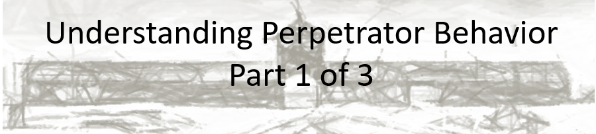

Best practices for making and using notes?
- Write them down, do not just type them up.
- Do not try to record verbatim.
- Review the content by first attempting to answer the essential question defining the lecture, and then make yourself aware of what you do not remember, questions that you have.
- Review notes for related lectures.
- Create a timeline of events to develop awareness of sequence of events and their significance to the lecture goals.

Essential Questions to Ponder; you should be able to write responses to each of these questions upon completing the recorded lectures and any relevant reading assignments:
- What motivated the perpetrators?
- Were they “ordinary” men?
- How did group dynamics influence perpetrator behavior?

Dr. Stallbaumer’s lecture thesis:

The following explanations have been offered to explain perpetrator behavior. What are the explanations, and why are none of them wholly sufficient explanations?
- Antisemitism
- Racism
- Fanaticism
- Antisocial Personality Disorder
- “only following orders”
- Evil

