

**Best practices for making and using notes?**

* Write them down, do not just type them up.
* Do not try to record verbatim.
* Review the content by first attempting to answer the essential question defining the lecture, and then make yourself aware of what you do not remember, questions that you have.
* Review notes for related lectures.
* Create a timeline of events to develop awareness of sequence of events and their significance to the lecture goals.

**Essential Questions to Ponder:**

1. How did Jewis respond to persecution during the killing years?
2. How does the definition of resistance influence interpretation by historians and yourself?
3. What were the obstacles to resistance?
4. **What types of resistance did Jews offer?**

**Revisit your beliefs about resistance. Which of these might you consider resistance?**

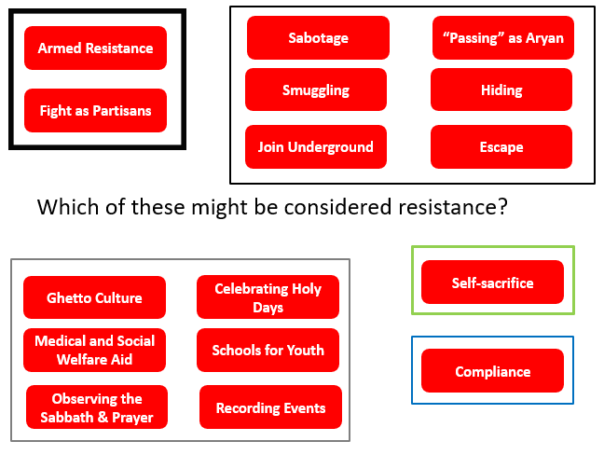

**What is the criteria that might shape your definition of resistance**? Be able to explain what behaviors were involved and defend your choices for discussion. How would you evaluate the examples below given your criteria?

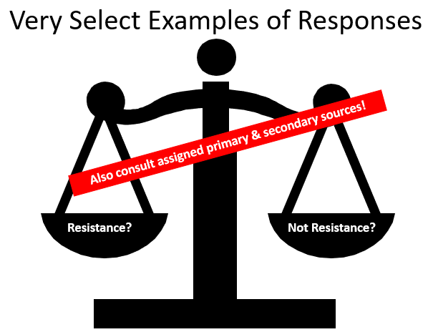

|  |  |  |
| --- | --- | --- |
| Examples | Your Opinion | |
|  |  |
|  |  | |
|  |  | |
|  |  | |
|  |  | |
|  |  | |
|  |  | |
|  |  | |
|  |  | |
|  |  | |
|  |  | |
|  |  | |
|  |  | |
|  |  | |
|  |  | |
|  |  | |
|  |  | |
|  |  | |
|  |  | |
|  |  | |
|  |  | |
|  |  | |