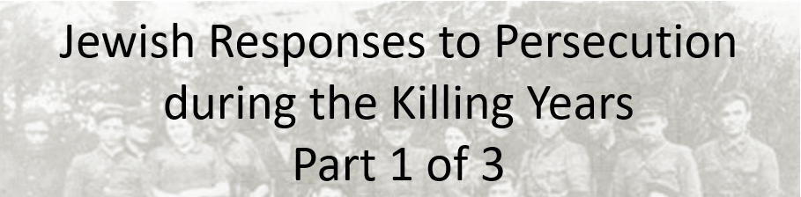

Best practices for making and using notes?
- Write them down, do not just type them up.
- Do not try to record verbatim.
- Review the content by first attempting to answer the essential question defining the lecture, and then make yourself aware of what you do not remember, questions that you have.
- Review notes for related lectures.
- Create a timeline of events to develop awareness of sequence of events and their significance to the lecture goals.

Essential Questions to Ponder:
- How did Jewis respond to persecution during the killing years?
- How does the definition of resistance influence interpretation by historians and yourself?
- What were the obstacles to resistance?
- What types of resistance did Jews offer?

What is your definition of resistance?

What are the possible range of responses?

Which of these would you consider resistance? Why?
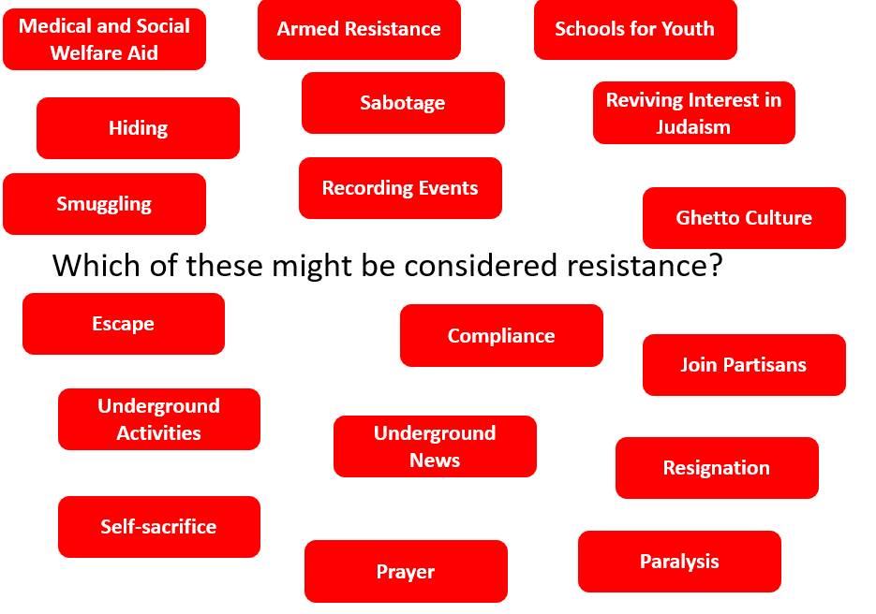
What working assumptions might professional historians make that influence their study of resistance? Three historians identified in this lecture include: Raul Hilberg, Yehuda Bauer, and Michael Marrus.

Michael Marrus: “Observers sometimes set arbitrary standards for Jewish populations, assume that the incidence of physical resistance among them should have been high, then seek esoteric explanations as to why this was not so. The case of Soviet prisoners of war highlights how unfair this approach can be. … [S]ome 3.3 million out of a total of 5.7 million Soviet prisoners perished while in German custody, most of them executed, starved, or worked to death; yet we have no knowledge of any important uprising until the very end of the war among these victims …” (The Holocaust in History, p. 140)

