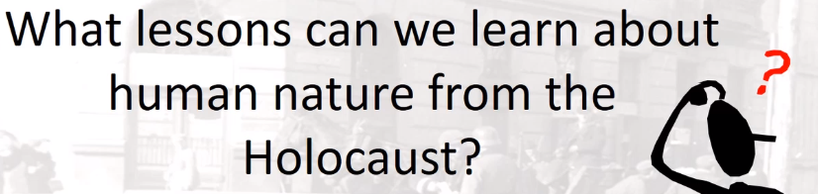

Best practices for making and using notes?
- Write them down, do not just type them up.
- Do not try to record verbatim.
- Review the content by first attempting to answer the essential question defining the lecture, and then make yourself aware of what you do not remember, questions that you have.
- Review notes for related lectures.
- Create a timeline of events to develop awareness of sequence of events and their significance to the lecture goals.

Be able to answer this question drawing upon Stallbaumer’s interpretation in the recorded lecture:
- What is your view of human nature?
- How will your understanding of human nature influence your interpretation of Nazism, the Holocaust, and specifically behaviors of perpetrators and victims?
- What lessons can we learn about human nature from the Holocaust?

Definition or characteristics of human nature

Be able to explain the difference between nature and nurture

Define innate, fixed, malleable

Film Clips:
- Testimony of Avraham Kochavi
- Testimony of Petra Zelionka
- “Decent People” Excerpt from Himmler Speech

What are the levels of Maslow’s Hierarchy of Needs? How does that help us think about behaviors in extreme situations?

What do philosophers say about individual choice and free will?

Text Heavy Slides:

Myra L. Impromptu Self: Myra was a nurse in a ghetto hospital. All the patients were being deported to the east. A cousin of hers attempts to hide but the Germans find her and drags her away. The cousin screamed at Myra to save her, but Myra did nothing. “’I couldn’t save her. I also feared that I can be taken instead. And that’s another thing that worked on me – that I couldn’t save her. I did not probably want to go for … my cousin the survival will was so big that nobody was sacrificing himself for anybody else.’” Langer, Holocaust Testimonies, 126.

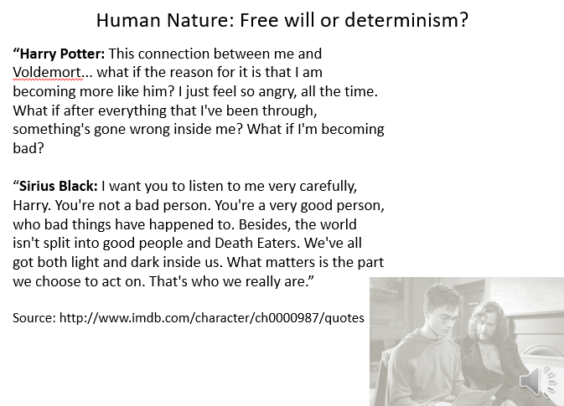

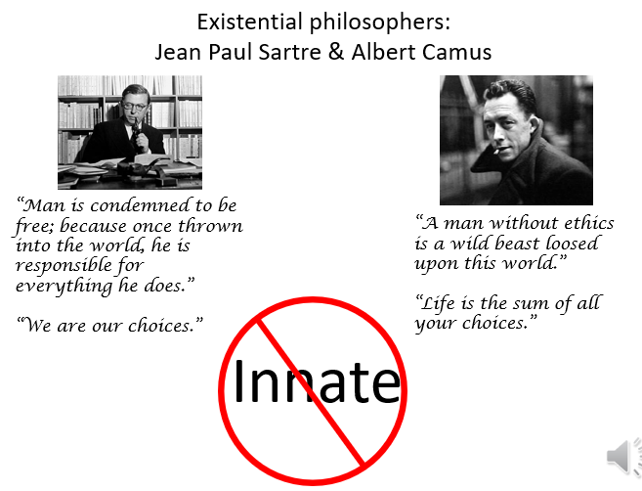

“Hell, according to the French philosopher Jean-Paul Sartre, is a self-service cafeteria – the worst suffering, in other words, is that which you inflict on yourself. Nazi planners seem to have understood that concept instinctively. By forcing Jewish leaders to involve themselves in decisions about the fate of people in the ghettos they both lightened their own sense of responsibility and increased the suffering within the Jewish community. Powerless as they were, the Jewish Councils had painfully few options. In a lose-lose situation where the options were destruction or destruction – death or death – there could be few, if any, right decisions. It should not be surprising that Jewish leaders based their strategies on the only two hopes available to them: that the Germans would be defeated sooner rather than later, and that somehow at least some Jews could be kept alive until that day.”
~ Doris Bergen, War and Genocide, 2nd ed. 119

“We must choose our language carefully here. Victims were not reduced to certain behavior by their hunger; they were driven to it. One term is judgmental, the other is not. But it is clear from the struggle of many witnesses, from their expressions as well as their words, that they inhabit two worlds simultaneously: the one of ‘choiceless choice’ then; the other of moral evaluation now. “
~ Lawrence Langer, Holocaust Testimonies: The Ruins of Memory (1991), 83

