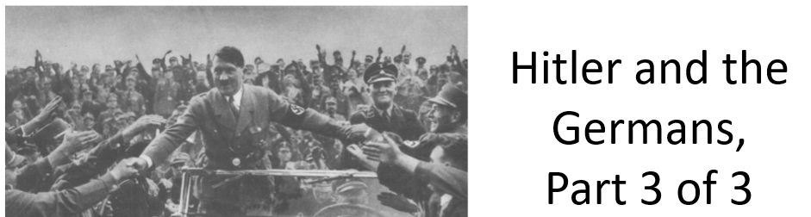

Best practices for making and using notes?
- Write them down, do not just type them up.
- Do not try to record verbatim.
- Review the content by first attempting to answer the essential question defining the lecture, and then make yourself aware of what you do not remember, questions that you have.
- Review notes for related lectures.
- Create a timeline of events to develop awareness of sequence of events and their significance to the lecture goals.

Upon completing part 3 of 3, you should be able to answer the following essential questions:

- Why the Germans?

What is Stallbaumer’s interpretation (i.e. thesis) to the following questions: Why the Germans? Why the Jews? How does she support her claims in the content of the lecture?
1.
2.
3.
4.
5.
6.

What were events in Germany in the 1920s that may have undermined the credibility of the Weimar Republic, which in turn made the rise of Nazism more possible?

By 1932, who voted Nazi and why?

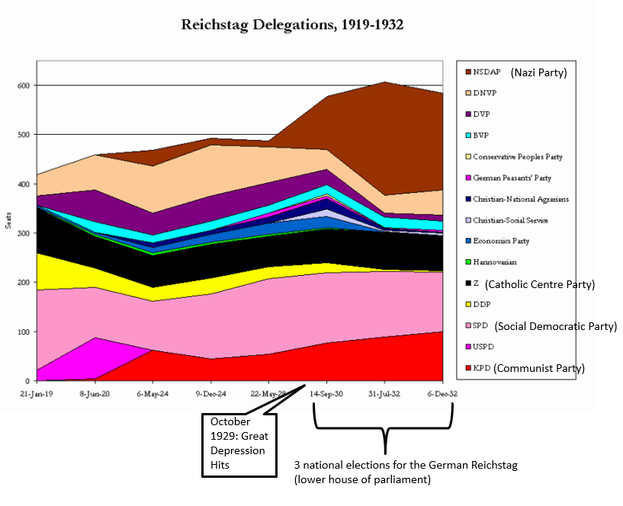

How did the Nazis establish a dictatorship between 1933-1934? Events and tactics to note:
Reichstag Fire
“Enabling” Law, 23 March 1933
Power of the Decree
Administrative Fiat
Nazi Party activists
Volksgemeinschaft
Incremental steps, daily choices

