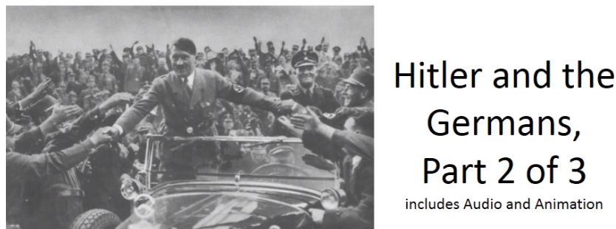

Best practices for making and using notes?
- Write them down, do not just type them up.
- Do not try to record verbatim.
- Review the content by first attempting to answer the essential question defining the lecture, and then make yourself aware of what you do not remember, questions that you have.
- Review notes for related lectures.
- Create a timeline of events to develop awareness of sequence of events and their significance to the lecture goals.

Be able to answer the following questions:

- Why Hitler?

What is Stallbaumer’s interpretation to the following question, Why Hitler and what was his role? How does she support her claims in the content of the lecture?

1.

2.

3.

4.

5.

Ian Kershaw: We come no closer to how "such a person could become ruler of Germany and how his ideological paranoia came to be implemented as a government policy by non-paranoids and non-psychopaths in a sophisticated, modern bureaucratic state."

What was Hitler’s role as “Der Führer” in the Nazi party and state?

What qualities were present to suggest that Hitler had charismatic leadership qualities?

Testimonials:
- "From this moment, I am born again, I am intoxicated."
- "One thing is certain: from that day on [when I first met Hitler] I had no other purpose than to fight for him until victory was won."
- "I had found myself, my leader and my cause . . . I had given him my soul."

Ian Kershaw: “readiness to accept an entirely different system of government based upon the exercise of personal power associated with personal responsibility.”

