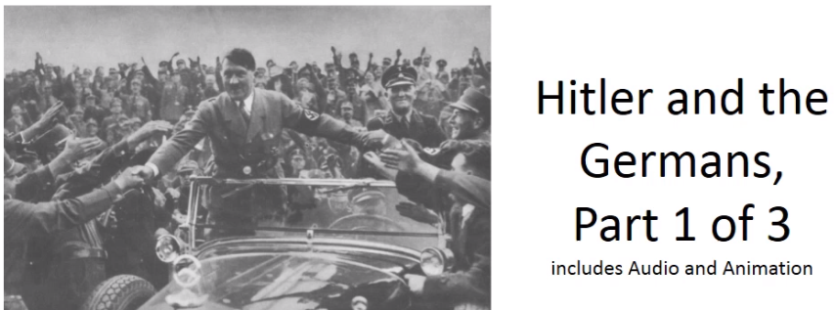

Best practices for making and using notes?
- Write them down, do not just type them up.
- Do not try to record verbatim.
- Review the content by first attempting to answer the essential question defining the lecture, and then make yourself aware of what you do not remember, questions that you have.
- Review notes for related lectures.
- Create a timeline of events to develop awareness of sequence of events and their significance to the lecture goals.

Be able to arrive at tentative answers to the following questions upon completing part 1 of 3:

- Why was the Holocaust unique?
- What is a “racial state”?
- Why Hitler? Why the Germans?
- How did “ordinary” Germans contribute to the racial state?

Terminology:
Holocaust
Shoah
Genocide
“Final solutions” – Endziel – Endlösung – Gesamtlösung
Volksgenosse

Why should we think of the Nazi state as being a “racial state” not just antisemitic?

Sterilization Law of 25 July 1933 (briefly describe and give significance):

Groups who Nazis labeled “racial enemies”:
1.
2.
3.
4.
5.
6.
7.
Other alleged threats:

