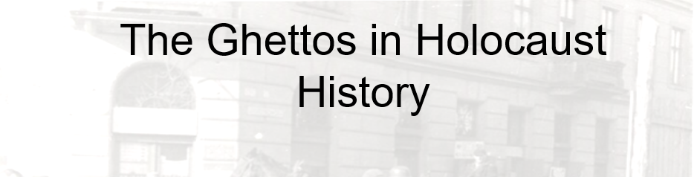

Best practices for making and using notes?
- Write them down, do not just type them up.
- Do not try to record verbatim.
- Review the content by first attempting to answer the essential question defining the lecture, and then make yourself aware of what you do not remember, questions that you have.
- Review notes for related lectures.
- Create a timeline of events to develop awareness of sequence of events and their significance to the lecture goals.

Essential Questions to Ponder:

- What are the conventional interpretations of the ghettos?
- What were contemporaries’ perceptions of their fellow Jews in the ghettos?
- What do we discover about persecution of Jews in the ghettos?
- What were the ghetto social and political structures? What was imposed by the Nazis? What were adaptations made by Jews?

Terminology and People
- Judenrat (plural: Judenräte)
- Jewish Police
- Emanuel Ringelblum
- Adam Czerniakow
- Chaim Rumkowski
- Warsaw
- Łódź
- Theresienstadt

Gustavo Corni: The ghetto inhabitants are viewed as "selfish and indifferent, and who tried to live from day to day by ignoring what was happening to others. . . . The ghettos, swarming with people and their innumerable social and cultural contradictions, have been branded as a phenomenon that only heroic death in combat or the tragedy of Auschwitz could (and should) erase." (Hitler’s Ghettos)

Doris Bergen: “Hell, according to the French philosopher Jean-Paul Sartre, is a self-service cafeteria – the worst suffering, in other words, is that which you inflict on yourself. Nazi planners seem to have understood that concept instinctively. By forcing Jewish leaders to involve themselves in decisions about the fate of people in the ghettos they both lightened their own sense of responsibility and increased the suffering within the Jewish community. Powerless as they were, the Jewish Councils had painfully few options. In a lose-lose situation where the options were destruction or destruction – death or death – there could be few, if any, right decisions. It should not be surprising that Jewish leaders based their strategies on the only two hopes available to them: that the Germans would be defeated sooner rather than later, and that somehow at least some Jews could be kept alive until that day.” (War and Genocide, 2nd ed., 119)

