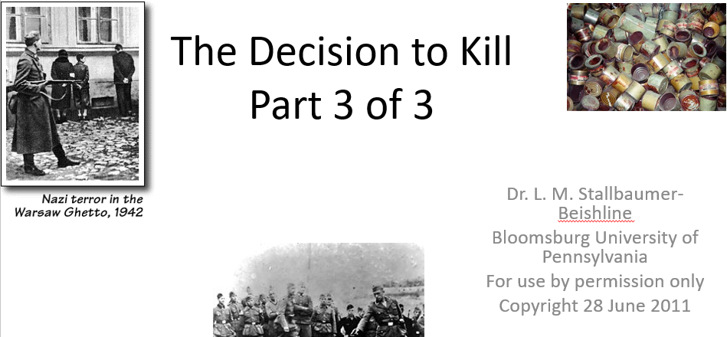

Best practices for making and using notes?
- Write them down, do not just type them up.
- Do not try to record verbatim.
- Review the content by first attempting to answer the essential question defining the lecture, and then make yourself aware of what you do not remember, questions that you have.
- Review notes for related lectures.
- Create a timeline of events to develop awareness of sequence of events and their significance to the lecture goals.

Lecture Goal:
To increase your awareness of the locations for permanent killing sites and how they differed from concentration camps.

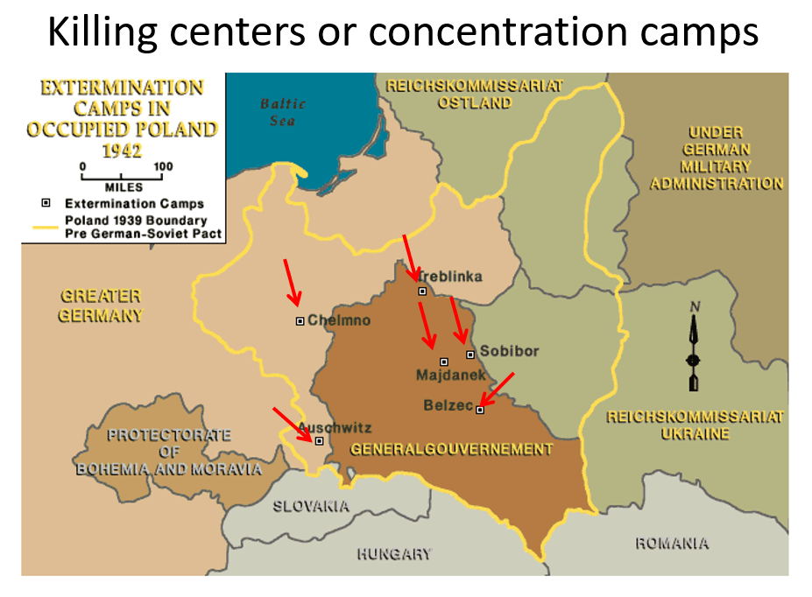
A camp not mentioned in the lecture is Maly Trostenets or Maly Trascianiec, located near Minsk. It began as a concentration camp to house Soviet prisoners of war (POWs), but it was made into an extermination camp in early May 1942. Most Jews were murdered by shooting, though mobile gas vans were also used.

