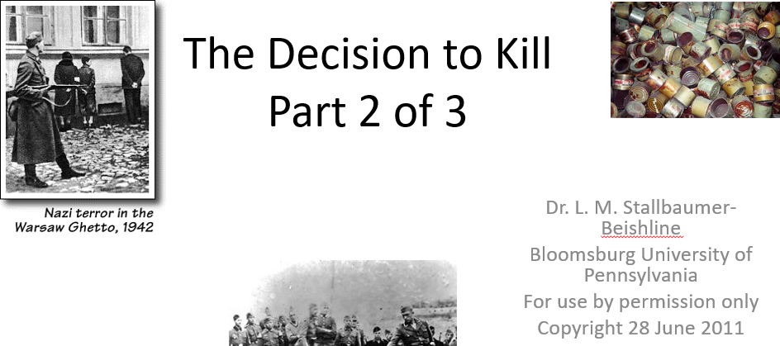

Best practices for making and using notes?
- Write them down, do not just type them up.
- Do not try to record verbatim.
- Review the content by first attempting to answer the essential question defining the lecture, and then make yourself aware of what you do not remember, questions that you have.
- Review notes for related lectures.
- Create a timeline of events to develop awareness of sequence of events and their significance to the lecture goals.

Essential Questions to Ponder:

- Who all was involved in the decision-making?
- When was the decision made?
- How was the decision made?
- Were all European Jews initially targeted?
- Or were groups selected in stages?

In this graphic, I outline my interpretation of the origins for the decision of the “final solution”. What is the interpretation? Pay attention to details for each slide. Is it plausible? Why or why not? | 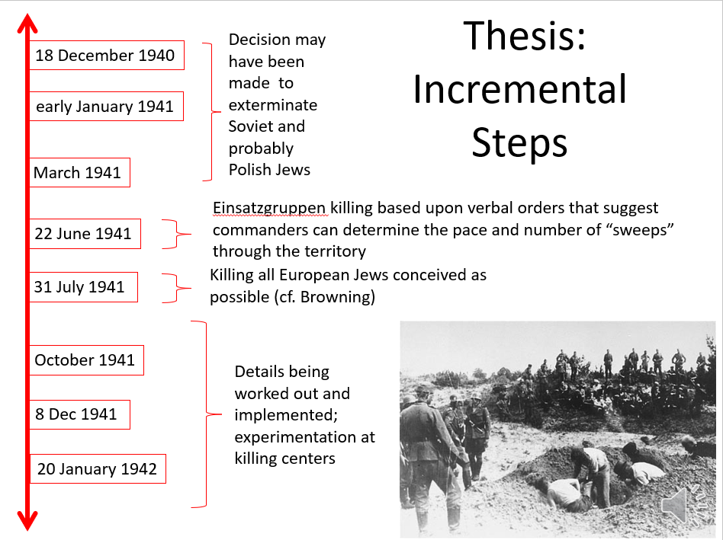

Names Brought Up in Lecture:
- Theodor Danneker
- Adolf Eichmann
- Reinhard Heydrich
- Heinrich Himmler
- Odilo Globocnik

Your notes:

