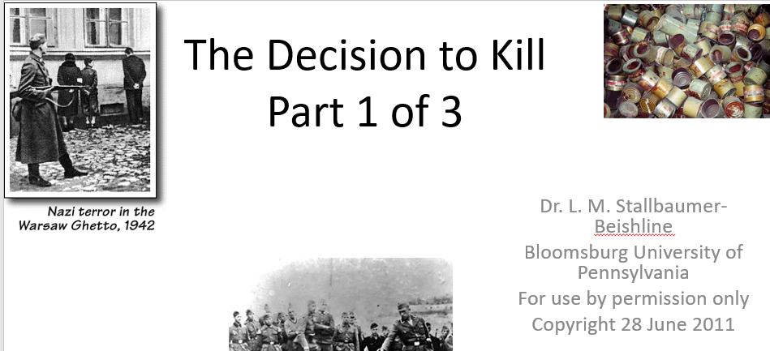

Best practices for making and using notes?
- Write them down, do not just type them up.
- Do not try to record verbatim.
- Review the content by first attempting to answer the essential question defining the lecture, and then make yourself aware of what you do not remember, questions that you have.
- Review notes for related lectures.
- Create a timeline of events to develop awareness of sequence of events and their significance to the lecture goals.

Essential Questions to Ponder:

- Who all was involved in the decision-making?
- When was the decision made?
- How was the decision made?
- Were all European Jews initially targeted?
- Or were groups selected in stages?

What are the challenges that researchers face in determining the origins of a decision to kill Europe’s Jews?

How will knowing the obstacles research influence your interpretation of the evidence?
What is the so-called euthanasia or T-4 program? What is your interpretation of how the T-4 program may have contributed to the origins of the decision to exterminate European Jews?

