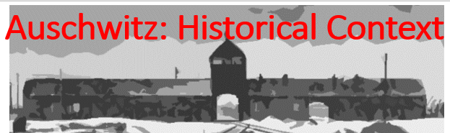

Best practices for making and using notes?
- Write them down, do not just type them up.
- Do not try to record verbatim.
- Review the content by first attempting to answer the essential question defining the lecture, and then make yourself aware of what you do not remember, questions that you have.
- Review notes for related lectures.
- Create a timeline of events to develop awareness of sequence of events and their significance to the lecture goals.

Essential Question:
Was Auschwitz intended to be an extermination camp from its inception?
What was the power structure in Auschwitz and how did it impact Jewish prisoners?

- Be able to explain the difference between Concentration, Labor, and Extermination Camps.
- What are the extermination camps:
- What was the power structure?
- Who were the prisoner groups?
- What were the conditions in Auschwitz?

