Final Examination University Seminar – Fall 2003
- Todd is easily distracted when studying. Jess has some ideas on improving the effectiveness of Todd’s study time. Describe three of Jess’ ideas.
- Next semester you are assigned a major research paper on a subject of your choice related to the course. It is due the 10th week of class. It must be a minimum of 20 pages in length and have a minimum of 20 references. What is the best way to approach this overwhelming assignment? Give at least three specific suggestions.
- Think about how college expectations are different from those in high School. Explain 3 effective ways to address college expectations.
- Below are sets of key words four professors typically use in their exams. Indicate the VARK preference of each professor and briefly explain your reasoning.
Dr. Darkstar: give examples, apply, demonstrate, from your experience
Dr. Organika: discuss, describe, explain
Dr. Deathbox: define, analyze, develop the case for, examine
Dr. Supernaut: illustrate, show, outline, label
- What is your dominant learning style (VARK)? What strategies can you use to take advantage of your learning preference?
- Why is it important to read and think before you highlight or mark your textbook?
- Indicate on which floor or floors (1, 2, 3, 4) of the library you can find each of the following. (2 pts each)
- __________ reference books
- __________ group study rooms
- __________ last week’s issue of Science
- __________ bound copies of Science from 1997
- __________ books on biology
- __________ photocopiers
- Identify one speaker you heard at Bio Career Night, indicate where s/he works, and summarize her/his presentation.
- Rank the following people from lowest to highest blood alcohol level after each has drunk two beers. Briefly explain the reasoning for your ranking.
  - BillyJean - 115 lb. ♀
  - Butch - 150 lb. ♂
  - Amelda - 150 lb. ♀
  - Crafty - 180 lb. ♂, athlete
  - Starchy - 180 lb. ♂, couch potato
- Calculate the Fall GPA, Spring GPA, and cumulative GPA of a student who has the following grades at the end of the freshman year. Show all your calculations below.
FALL SEMESTER |  |  | SPRING SEMESTER
COURSE | CREDITS | GRADE | COURSE | CREDITS | GRADE
University Seminar | 1 | A | Concepts of Biology II | 4 | B
Concepts of Biology I | 4 | A | Intro Statistics | 3 | A
Fundamentals of Inorganic Chemistry | 4 | C+ | Chemical Principles and Measurements | 4 | C-
Composition I | 3 | B+ | Interpersonal Communication | 3 | B+
General Psychology | 3 | B- | Principles of Economics I | 3 | C
FALL GPA |  |  | SPRING GPA
CUMULATIVE GPA

- Name 4 other students in this class other than yourself.
- What is a “high yield” portion of text?
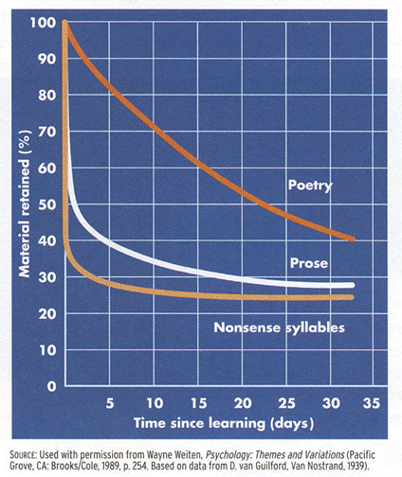
- a) What does this graph say? b) What are two things that you can before, during and after class (two things each), that can help you retain information?

- Final thing: give me a unique, 5-character identifier so that I can post your grade at the end of the semester. Your identifier should be recognizable to you only and have no part of your social security number in it. Your grade will be posted outside my office a day or two after you turn in your final assignment.

Unique Identifier ______________________

